Meta-data accompanying Figure Set on Stress and strains under uniform strip load

Brief title: Stress and strain under uniform strip load
Descriptive figure set title: Vertical, horizontal and shear stress increment under a uniform strip load. Comparison between analytical solution, based on Boussinesq theory, and numerical solution with FEM. Comparison between results of linear elastic constitutive model, elastic perfectly plastic model and Modified Cam Clay model.
SMGE issue/concept: Stress increment under a uniform loaded area and corresponding displacements
Course chapter/topic: Stress increment under loaded area
Figure Type: The material includes MATLAB figures, PNG figures, Excel sheets, PowerPoint slides, and FEM models.
Brief Articulation of figures MAIN IDEA: The main idea of the provided material is to illustrate and compare the analytical solution (based on Boussinesq theory) and the numerical solution (using finite element method) for calculating the vertical, horizontal, and shear stress increments under a uniform strip load on a soil surface. The effect of Young modulus on displacement is discussed. It is also shown that changing the constitutive model to Modified Cam Clay the stress distribution remains similar, but the displacement distribution changes completely.
Author name: Francesca Ceccato
Author e-mail: francesca.ceccato.1@unipd.it

Additional material

Analitical solution based on Boussinesq theory
The distribution of stresses within a soil from applied surface loads or stresses can be determined analytically by assuming that the soil is a semi-infinite, homogeneous, linear, isotropic, elastic material. A semi-infinite mass is bounded on one side and extends infinitely in all other directions; this is also called an “elastic halfspace”.
For soils, the horizontal surface is the bounding side. The increases in soil stresses from surface loads are total stresses. These increases in stresses are resisted initially by both the porewater and the soil particles. Equations and charts for several types of flexible surface loads based on the above assumptions are available in many geotechnical textbook. This set of figures focuses on the load increment generated by a strip load. A strip load is the load transmitted by a structure of finite width and infinite length on a soil surface.
The analytical solution for this case provides the following equations for vertical stress, horizontal stress and shear stress:
$$∆σ_{z}=\frac{q}{π}\left[α+\sin{α}\cos\left(α+2β\right)\right]$$
$$∆σ_{x}=\frac{q}{π}\left[α-\sin{α}\cos\left(α+2β\right)\right]$$
$$∆τ_{zx}=\frac{q}{π}\left[\sin{α}\cos\left(α+2β\right)\right]$$

q is the applied load per unit of area and the geometric quantities are defined in Figure 1:

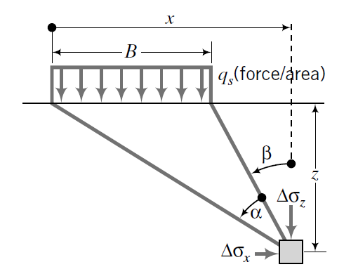 | 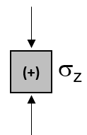 | 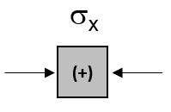 | 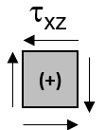
Figure 1 Definitions for the calculation of stress increment.
These equations are implementented in Matlab to prepare three contour figures of normalized stress increments ($∆σ_{z}/q$, $∆σ_{x}/q$,$∆τ_{zx}/q$) with normalized coordinates (X/B, Z/B) with origin in the centre of the loaded area.
Matlab figures (.fig files) can be open in Matlab and inspect values at different points.
Key insights from Figure 2:
- The highest stress concentration occurs directly beneath the center of the strip load.
- Stress decreases as depth (Z/B) or distance form the centerline (X/B) increases, forming an approximately elliptical stress distribution.
- The contours illustrate the spread of stress within the soil, with the majority of the stress dissipating within a few multiples of B.
- The colour scale represents the magnitude of stress increment, with red indicating high stress and blue representing low stress.

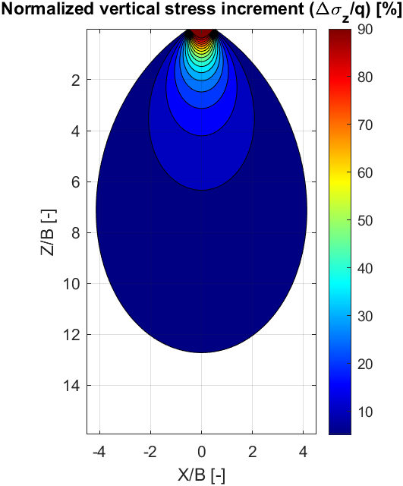
Figure 2 Normalized vertical stress increment from analytcal solution
Key observations for Figure 3:
- The maximum horizontal stress occurs near the edges of the strip load and extends outward in a butterfly-shaped pattern.
- Below the center of the strip load, horizontal stress is minimal or even negative (compressive in the opposite direction).
- Stress diminishes with increasing depth, indicating stress redistribution within the soil mass.
This figure helps students understand the complexity of lateral stress distribution under loading, which is crucial in retaining structures, slope stability, and foundation engineering.

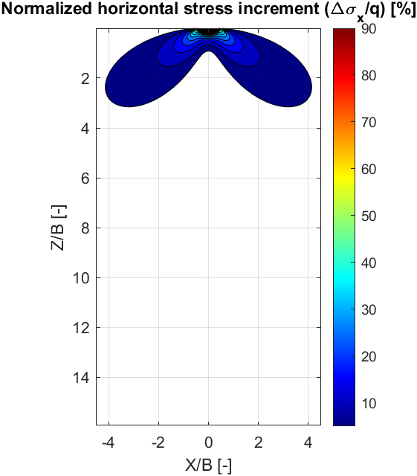
Figure 3 Normalized horizontal stress increment from analytcal solution
Key observations for Figure 4:
- The shear stress is antisymmetric about the centerline (X=0), meaning the left and right sides exhibit opposite signs.
- Maximum shear stress occurs just beneath the edges of the strip load, forming two distinct lobes—positive on the left and negative on the right.
- Shear stress rapidly decreases with depth, showing that it is concentrated near the surface and beneath the edges of the load.
- The transition between positive and negative shear stress occurs along the vertical centerline (X=0), where shear stress is zero.

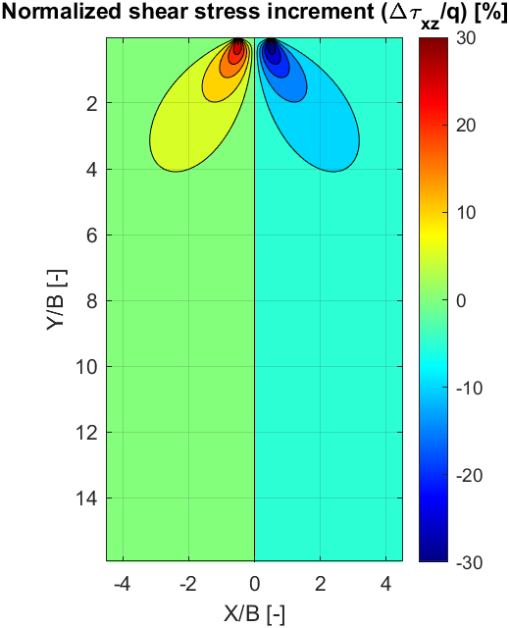
Figure 4 Normalized shear stress increment from analytcal solution
Values are also written in Excel, thus students and teachers can use it to create additional figures for their classes or provide assignments to students. Students may be asked to implement a similar spreadsheet or a code as an exercise, most undergraduate students certainly have the knowledge to do so.

The Excel file has 7 sheets with the following data:
- “Dimensions and load” where the value of the constant load on the area and the width of the loaded area are specified. Values on the green cells can be modified to get the correct values of stress increments in the following sheets.
- “DeltaSigmaZ”, “DeltaSigmaX”, and “DeltaTau” contain the values of the stress increments at each point with coordinates x and z given in the columns and rows. They change with the magnitude of load q given in the sheet “Dimensions and load”. X/B and Z/B are normalized dimensions, while x and z are calculated with the width of foundation given in sheed “Dimensions and load”, they will change with B.
- “DeltaSigmaZ_norm”, “DeltaSigmaX_norm”, and “DeltaTau_norm” contain the values of the normalized stress increments at each point with coordinates x and z given in the columns and rows. These normalized values do not change with q and B.

FEM simulations
The same problem is simulated with an FEM code SigmaW by Geostudio (v 2024). The 2D plane strain problem is simulated considering 6 different models where geometry, material constitutive model and material parameters are varied as follows (Table 1):
- Model 1 serves as a benchmark for analytical comparison, featuring a 100 kPa load on a 1m-wide strip with a linear elastic material and no gravity.
- Models 2 and 3 introduce gravity and a wider 2m strip load. Both use a linear elastic material, but with different values of Young Modulus. Model 2 represents a medium dense sand, while Model 3 simulates soft clay.
- Model 4 incorporates elasto-plastic behaviour using the Mohr-Coulomb failure criterion.
- Models 5 and 6 implement the Modified Cam Clay model with the load applied at the surface or at the bottom of a 0.5m excavation.
The author suggests to avoid the presentation of FEM figures to students that do not have any basic knowledge of the method or to do it with care in order to avoid that this method is perceived as superior, more realistic and always preferable to analytic solutions. Indeed, the quality of FEM results depends on the ability of the engineer to define correctly the model, i.e. geometry, boundary conditions, material parameters, calculation parameters. Teachers of advanced courses should encourage students to compare results of FEM with analytical solutions, discussing differences and similarities, advantages and limitations of the methods.
Table 1 Features of numerical models
Feature | Model 1 (Analytical Comparison) | Model 2 (Elastic - Medium Dense Sand) | Model 3 (Elastic - Soft Clay) | Model 4 (Mohr-Coulomb - Medium Dense Sand) | Model 5 (Modified Cam Clay) | Model 6 (Modified Cam Clay - Excavation)
Load Entity | 100kPa | 100kPa | 100kPa | 100kPa | 100kPa | 100kPa
Load Width | 1m | 2m | 2m | 2m | 2m | 2m (applied at excavation bottom)
Material Model | Linear Elastic | Linear Elastic | Linear Elastic | Elastic-Perfectly Plastic (Mohr-Coulomb) | Modified Cam Clay | Modified Cam Clay
Material parameters | E=30000kPa, ν=0.3 | E=30000kPa  ν=0.3 | E=1000kPa  ν=0.3 | E=30000kPa  ν=0.3  ϕ=35° | Table 2 | Table 2
Soil Unit Weight | 0 | 20 kN/m³ | 20 kN/m³ | 20 kN/m³ | 20 kN/m³ | 20 kN/m³
Notes | No gravity, used for comparison with analytical solution | Simulates medium dense sand | Simulates soft clay | Sher failure mechanism included in the model | This model has convergence issues | Load applied at excavation bottom

Table 2 Material parameters and initial state parameters of Modified Cam Clay model
Initial void ratio [-] | e₀ | 1.0
Overconsolidatio Ratio [-] | OCR | 2.0
Poisson ratio [-] | ν | 0.3
Slope of critical state line [-] | λ | 0.32
Slope of loading reloading line [-] | κ | 0.07
Unit weigth [kN/m³] | γ | 20
Friction angle [°] | ϕ | 28

Model 1
To facilitate the comparison, the foundation is 1m and it is loaded with 100kPa. To compare the results with analytical solution, the material is linear elastic, gravity is neglected and the model boundaries must be very far (elastic halfspace). In advanced courses the teacher can ask to the students to simulate this example as an exercise.
Results are shown below. Increments in mean effective stress and deviatoric stress are added for completeness.

Figure 5 Normalized vertical stress increment from FEM
Figure 6 Normalized horizontal stress increment from FEM
Figure 7 Normalized shear stress increment from FEM
Figure 8 Normalized mean stress increment from FEM
Figure 9 Normalized deviatoric stress increment from FEM
The figures are then elaborated in Power Point to provide a more effective comparison between analytical and numerical solution and prove that they are equivalent. Instructors can use and modify these slides.
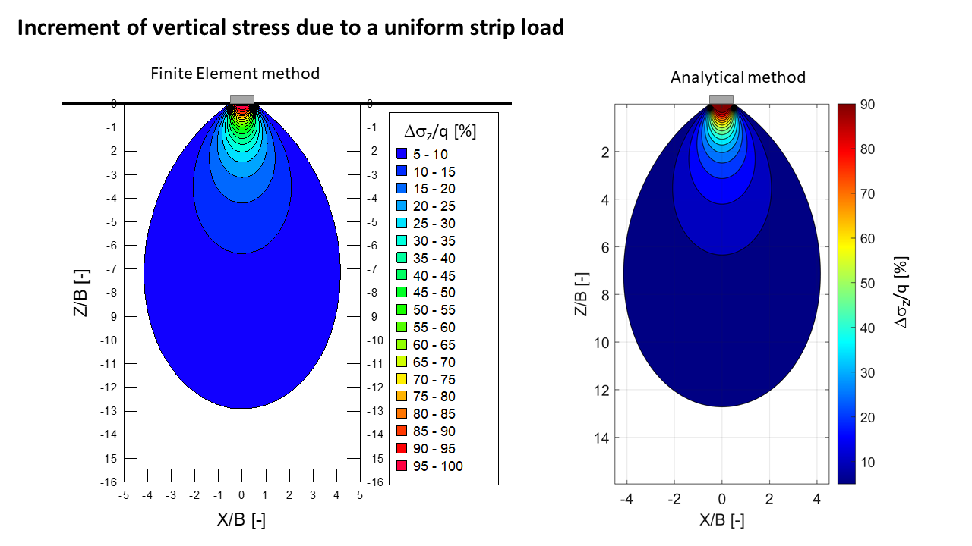
Figure 10 Vertical stress increment: comparison between FEM and anlytical solution
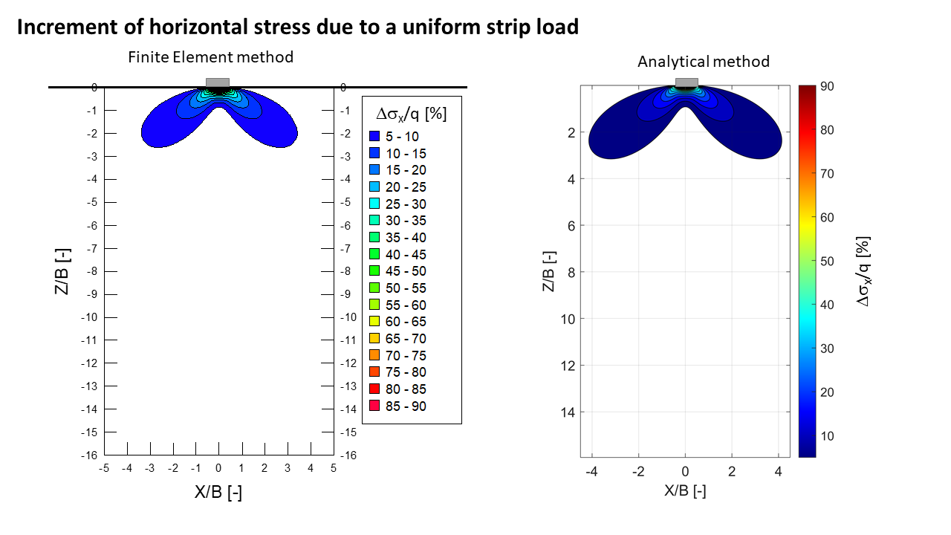
Figure 11 Horizontal stress increment: comparison between FEM and anlytical solution
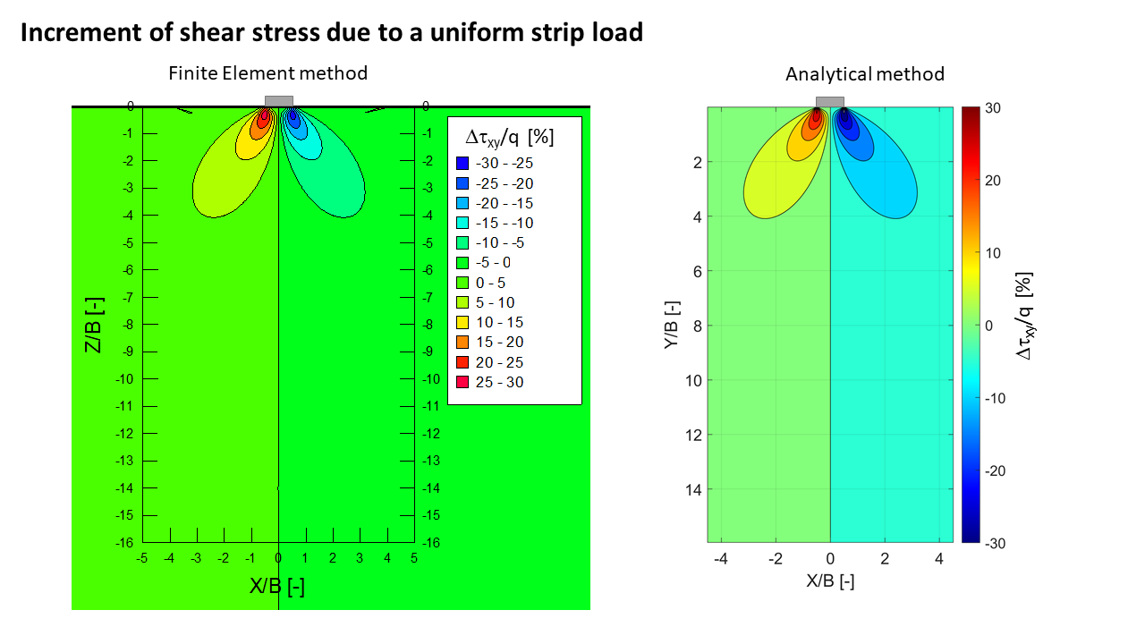
Figure 12 Shear stress increment: comparison between FEM and anlytical solution
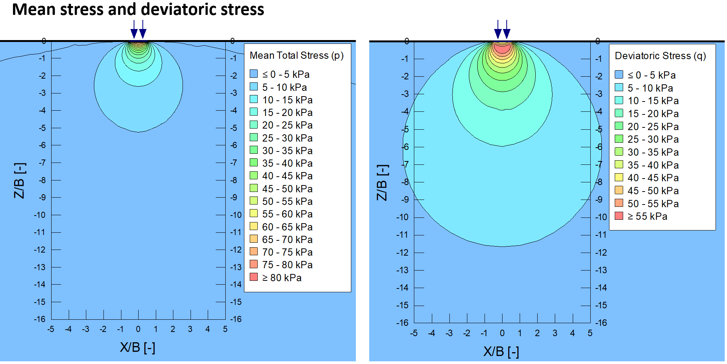
Figure 13 Mean and deviatoric stress increment

The teacher that wants to enrich the discussion on FEM, may show the students that the distance of boundaries totally changes the results. If the boundaries are too close to the loaded area, the results do not match the analytical solution.
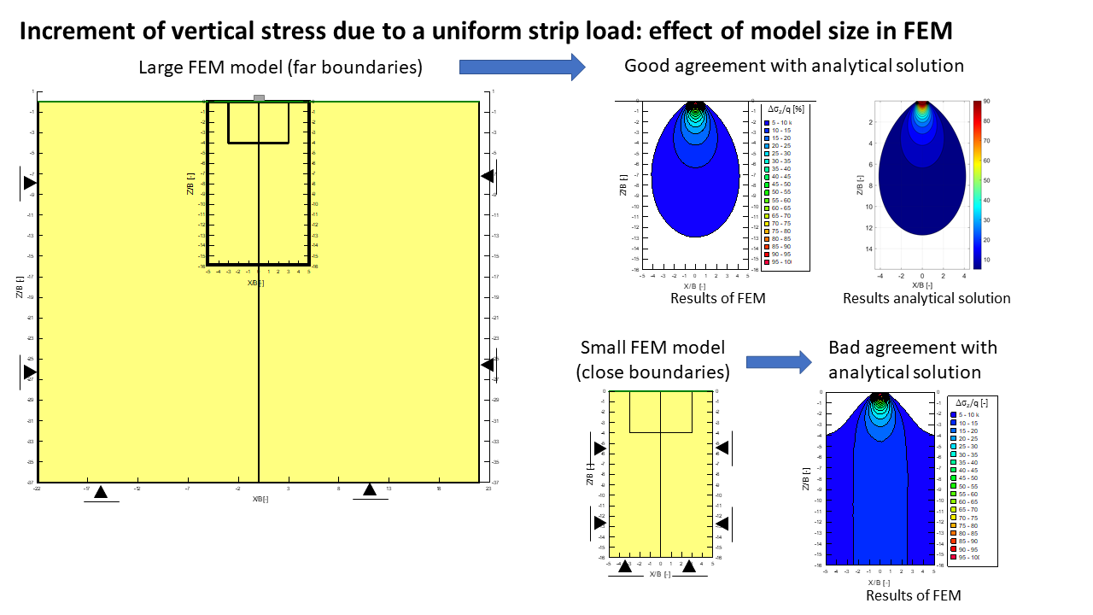
Figure 14 Effect of model boundaries in FEM

Model 2 and 3
Consider now a 2m-wide foundation (B=2m) uniformly loaded with q=100kPa. Soil is linear elastic with unit weight γ=20kN/m³, Poisson’s ratio ν=0.3, and two values of Young modulus are used for comparison: E=30 000kPa, which is typical of a medium sand, and E=1000kPa, which is typical of a soft clay. The teacher may ask to the student what they believe the differences could be asking questions such as:
- How does an increase in Young's modulus (E) affect the vertical stress distribution beneath a strip load?
- What is the relationship between Young's modulus and vertical displacement under a strip load (linear, non-linear)? If E increases, how does the settlement change, and why?
- In soft soils (low E) and stiff soils (high E), how does the shape and extent of the stress distribution differ? How would this affect foundation design choices?

Figure 15a shows that the vertical stress increment is not affected by the Young modulus. In contrast, the displacement is significantly different, the maximum displacement at the centreline is 0.153m in case E=30000kPa (medium sand) and 0.46m in case E=1000kPa (soft clay). The relationship is linear because the soil is assumed homogeneous and linear elastic.
At a distance of 3m from the centreline, the surface displacement is 48% of the maximum, which correspond to 0.223m for E=1000kPa and 0.007m for E=30000kPa. It is necessary a distance of 19m to reach a surface displacement of only 10% of the maximum.

(a)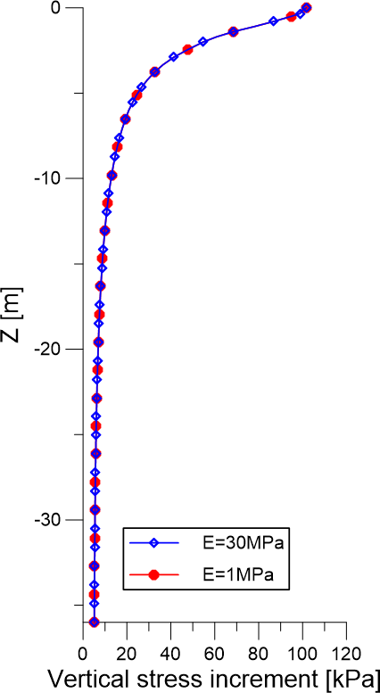 | (b)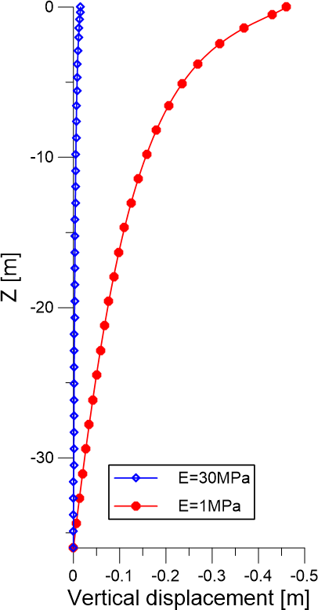
(c)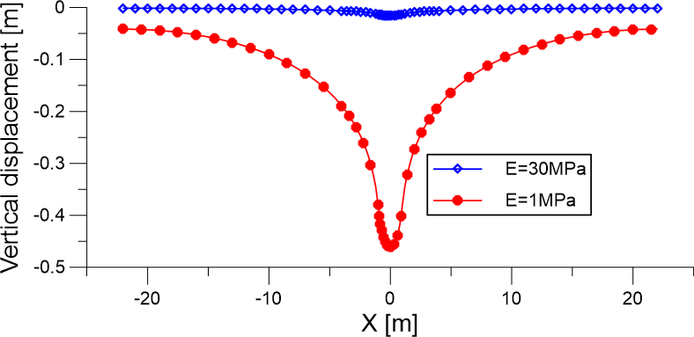
Figure 15 Effect of Young modulus on (a) vertical stress increment, (b) vertical displacement at the centerline, (c) vertical displacement at the surface

Model 4
Consider now an elastic-perfectly plastic soil with Mohr-Coulomb failure criterion. Assume reasonable parameters for a medium sand such as friction angle equal to 35° and zero cohesion. The teacher may ask to the students to calculate the bearing capacity and what differences with respect to elastic model they expect in terms of settlements.
Since the load is much smaller than the bearing capacity of the foundation, the material behaviour is elastic because the yield condition is not reached. The contour and distribution of surface displacement are identical to the linear elastic case. This fundamental understanding of soil behaviour and the difference between serviceability limit state (SLS) and ultimate limit state (ULS) is an important aspect that student should learn.
Figure 16 Vertical displacement contour

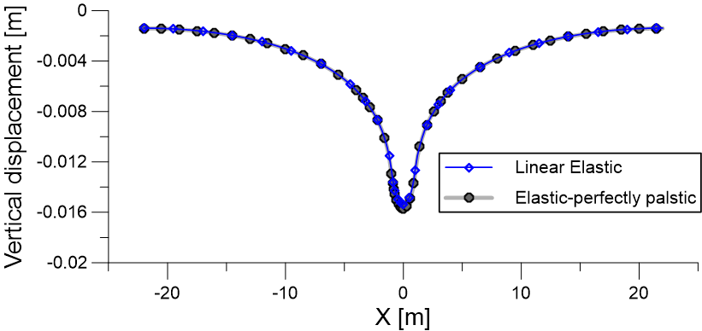
Figure 17 Vertical displacement at the surface
At this point, the teacher should ask if this constitutive model is realistic and what are the limitations of the assumptions. Soil behavior, especially in soft clays, is not linear elastic, thus a model including non-linear compressibility should be used. A possibility is the use of Modified Cam Clay (MCC), which is often included in many soil mechanic courses.

Model 5 and 6
The same model used in the previous examples is considered, but the material constitutive model is changed to Modified Cam Clay and the parameters are listed in Table 2. This FEM model does not converge because at low confining stress the stiffness is too small. The teacher can discuss with students what could be the possible solutions, for example: consider an excavation, consider the presence of a dry crust or stiffer soil at the surface etc...
Foundations are never settled at the ground surface, in this case we consider a small excavation of 0.5m. The FEM simulation has now 3 load steps:
- Generation of in-situ stresses
- Excavation of small portion of soil to accommodate the foundation
- Application of foundation load
Now the model converges and the results can be compared with the one obtained with the Linear Elastic model and Young modulus 1000kPa.
Comparing Figure 18 and Figure 19 students should capture that, due to non-linear soil compressibility, the maximum displacement is higher with MCC model, but the extend of displacement is much more limited. This is not due to a significantly different vertical stress increment (Figure 20), but to the stress-strain behavior of the material. With MCC model the vertical displacements are concentrated closer to the foundation, see also Figure 21. A discussion on the practical implications of these observations is encouraged.
Figure 18 Vertical displacement contour for soft clay modelled with Modified Cam Clay
Figure 19 Vertical displacement contour for soft clay modelled with Linear elasticity
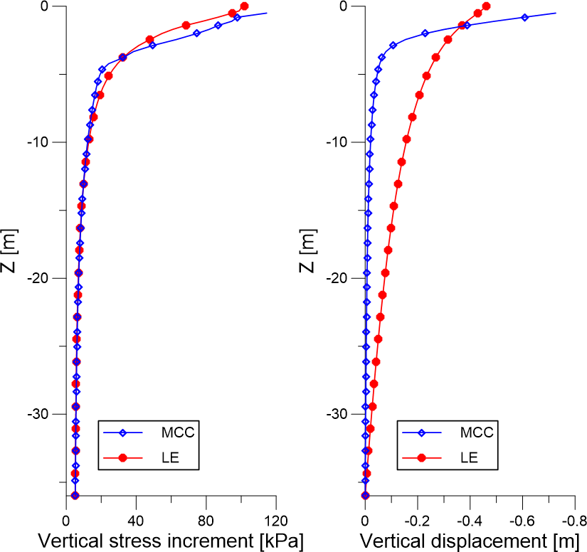
Figure 20 Vertical stress increment and vertical displacement with depth at the centerline. Comparson between linear elasticity and Modified Cam clay
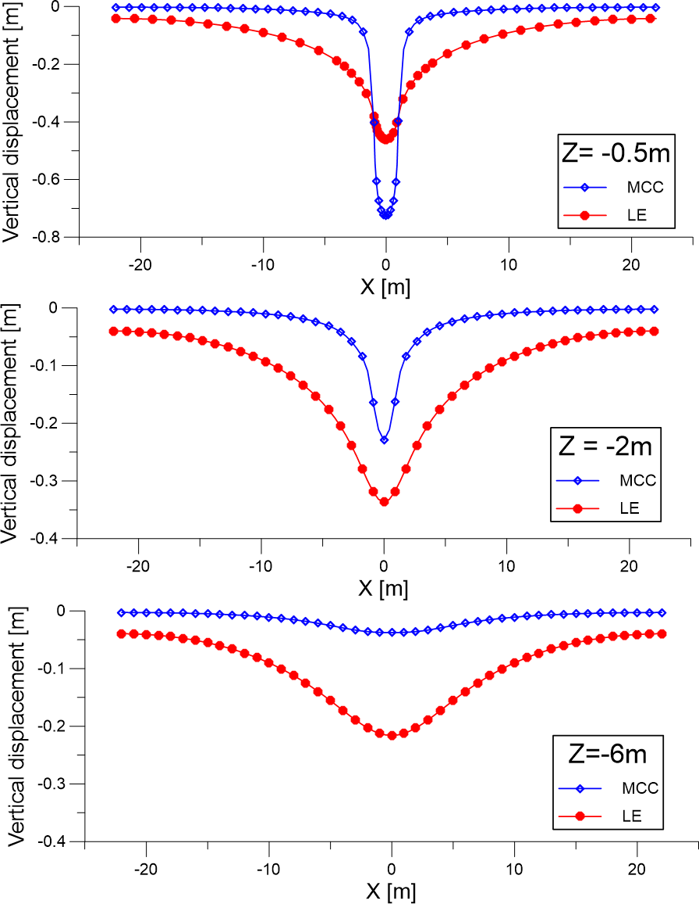
Figure 21 Vertical displacement with distance from centerline at different depths. Comparson between linear elasticity and Modified Cam clay

Suggestions for advanced courses
While the analytical solution is developed under the hypothesis of homogenous, isotropic, linear elastic halfspace, FEM can be used to explore many different conditions such as stratified soil, the effect of soil constitutive model, material parameters, type of load (e.g. non uniform, inclined, applied on rigid or semi-rigid foundation, etc.). Teachers of advanced courses can certainly assign this task to their students, examples are:
- Effect of material parameters on displacements, e.g. friction angle of EP models, λ,κ, OCR, etc. on MCC model;
- stratified subsoil (different linear-elastic materials or elasto-plastic materials) instead of a homogeneous domain;
- change foundation width, load distribution;
- introduce foundation stiffness.

License
The provided material is shared under the Creative Commons Attribution (CC BY) license, which allows for free distribution, modification, and commercial use, as long as appropriate credit is given to the original author(s) and any changes made are indicated.

Copyright © [2025] [Francesca Ceccato]. This work is licensed under a Creative Commons Attribution 4.0 International License. https://creativecommons.org/licenses/by-nc-sa/4.0/deed.it

