Changing attitudes, organization and scale in engineering education:
The teacher as a go-between and TC306 as a knowledge broker
Marina Pantazidou
DRAFT SUPPLEMENT – WILL BE FINALIZED FOLLOWING PEER REVIEW OF FIGURES S1, S3-S11
This draft supplement includes teaching materials for instructors contemplating whether or not and how to teach soil compaction in an introductory soil mechanics or geotechnical engineering course.

Contents | Page
Table S1. Introductory and specialty textbooks surveyed for the topic of soil compaction listed in order from oldest to most recent based on their first edition dates | 2
Text S1. Annotated list of references of the surveyed books | 3
Figure S1. Proposed textbook-case compaction curve (Figure 2 in paper) with commentary on key features | 8
Figure S2. Compaction curves plotted as specific volume, v, against water content, w: graph by Powrie (2014), used by permission | 10
Figures S3-S7. Set of one figure with grain size distribution curves of four soils and four figures, one for each soil, with compaction curves obtained in the laboratory at different levels of compactive energy and in the field using different compaction methods | 11
Figure S8. The big idea “soil particles are to soil what yarn is to textile” is illustrated with compaction curves of four different soils (Figure 5 in paper) | 14
Figures S9-10. Examples of compaction curves using different measures of density (Figure 3 in paper) | 15
Figure S11. Compaction curves with dry unit weight plotted against water content or degree of saturation (Figure 4 in paper) | 17
Text S2. Note on compaction standards (tentative) | 18
Text S3. Note on static vs dynamic compaction (conjectural) | 21


Suggested reference: Pantazidou, M. (2025). Draft Supplement to “Changing attitudes, organization and scale in engineering education: The teacher as a go-between and TC306 as a knowledge broker”, 3rd John Burland Lecture. Proc. of the ISSMGE Int. Conf. Geotechnical Engineering Education 2025 (GEE 2025), Nancy, France, July 2-4, Calvello, M., Pantazidou, M., Pinho-Lopes, M. (Eds.). CC BY 4.0, with the exception of Figure S2.

Table S1. Introductory and specialty textbooks consulted for the topic of soil compaction, listed in order from oldest to most recent based on their first edition dates.
Author (year of reviewed edition/year of 1st ed.)* | Chapter No (out of total number of chapters) and name | Section (in the absence of dedicated chapter) | Brief comments*
Introductory textbooks
Taylor (1948) | 18(20): Soil Mechanics issues related to dams | 18.2 Compaction | Acknowledges alternative measures to represent soil density. Balanced emphasis on strength and imperviousness.
Terzaghi & Peck (1967/1948) | 8(12): Earth pressure and stability of slopes | Article 50 (69): Compaction of soils | Emphasis on field applications. Makes clear the difference between cohesionless soils and sands-silts with moderate cohesion.
Sowers (1979/1951) | 6(12): Earth and rock construction | 6.2 Compaction Mechanics | Mostly descriptive.
Lambe & Whitman (1979/1969) | 34(34): The improvement of soil | 34.1-34.6 Various aspects of compaction | Discusses saturation at optimum water content (and beyond) and effect of compaction on engineering behavior.
Knappett & Craig (2012/1974) | 1(13): Basic characteristics of soils | 1.7 Soil compaction | The only book showing the combined effect of compactive energy and soil type. (Proctor test description: problem with mentioning stipulation of removing particles greater than 20 mm).
Atkinson (2007/1993) | 26(28): Behaviour of unsaturated soils | 26.10 Compaction and compacted soils | From the way soils are described, it is implied that we deal only with soils with a high fraction of clays. Only conceptual figures.
Powrie (2014/1996) | 1(11): Origin and classification of soils | 1.12 Compaction | Succinct explanation of (un)desirable soils. Succinct description of Proctor test (but problem with mentioning stipulation of removing particles greater than 20 mm). Mostly conceptual figures.
Budhu (2011/2000) | 5(16): Soil compaction | 9.3 Compaction test: dry unit weight | A mixture of conceptual figures and figures with numbers in axes. Two sets of data of lab measurements (for un-named soils).
Briaud (2013) | 20(27): Soil compaction & 9(27): Laboratory tests |  | Mostly conceptual figures, i.e. compaction curves have no numbers in axes. All figures for un-named soils.
Specialty textbook
Bowles (1984/1979) | 7(16): Compaction and soil stabilization |  | Acknowledges that compaction originated in the study of fine-grained soils. The only textbook saying clearly that a compaction curve is usually not drawn to obtain maximum density of coarse-grained soils without fines.
Specialty book
Papaspyrou (2006) | 3-6(8): Six chapters on compaction |  | A specialty book on compaction of embankments, with dedicated chapters on clean coarse-grained soils, clayey sand-gravels and clays.
* For long references, excerpts and extended comments, see annotated reference list in Text S1.

Text S1. Annotated alphabetical list of references in Table S1. Includes comments and selected “excerpts in quotes” (mildly rephrased otherwise). Key figures are discussed.
Key for color highlights: values/range of degree of saturation at optimum points, minimal change of degree of saturation past the optimum point, comments on differences between coarse-grained and fine-grained soils, particularly thoughtful/cogent remarks or thoughts resulting from these remarks, denotes different book sections
Atkinson, J. (2007). The Mechanics of Soils and Foundations, 2nd edition (1st edition 1993), Taylor and Francis, London. Relevant Section: 26.10 Compaction and compacted soils
“Construction often involves excavation and use of soil in earthworks such as road and rail embankments, earthfill dams and land reclamation. When it is excavated, soil comes out of the ground in lumps [NOTE: by this description, it is implied that soil has a high fines content]; you can see this happening when you dig the garden. When it is placed, it must be compacted to make a stiff and strong engineering fill.” COMMENT: The section on compaction (26.10) is only two pages.
Bowles, G.E. (1984). Physical and Geotechnical Properties of Soils, 2nd edition (1st edition 1979), McGraw-Hill, New York. Relevant Chapter: 7 Compaction and soil stabilization. Key sections: 7.5 Theory of compaction, 7.6 Cohesionless soils, 7.7 Cohesive soils, 7.11 Compaction specifications
Section 7.5 The first and only book from those reviewed stating explicitly that compaction theory started with the study of compaction of fine-grained soils by R.R. Proctor in order to develop specifications for the construction of dams. [NOTE: slightly different historical account by Terzaghi & Peck.] Figure 7.1: two compaction curves for silty clay (optimums 13% and 16%), line of optimums with saturation less than 80%. “In most cases the optimum moisture content occurs at S=75 to 80 percent for the standard compaction test.” Figure 7.2: compaction curves for several soils (from a well-graded sand to a heavy clay), showing a trend of decreasing unit weight (from ~21kN/m³ to ~15 kN/m³) for increasing fine-grained percentage (passing the No 200 sieve). Section 7.6 Cohesionless “The usual method for compacting cohesionless soils is with a combination of confinement and vibration.” […] “Another method sometimes used is to flood (saturate) the soil and roll it – preferably with vibratory rollers” […]. “Saturation ensures breaking of any surface tensions from just damp soil and the roller creates excess pressure that liquefies the soil making it easy for the grains to move.” […] “In the laboratory, cohesionless soils are compacted by confining layers of dry soil in a compaction mold and sharply rapping the sides with a rubber mallet”.[…] “A curve is usually not drawn to obtain a maximum dry density.” Section 7.7 Cohesive “The structure and engineering properties of compacted cohesive soils will depend greatly on the method of compaction, the compactive energy and the water content at compaction”: wet of optimum, the compaction method has a significant effect on the soil fabric (but not dry of optimum). [Selected excerpts from pages 208-213]
Section 7.11 “The compaction test is generally used if the soil contains more than 12 percent fines but there is no reason that some type of unit weight test cannot be used for all soils to establish compaction specifications.” Useful order-of magnitude yardstick: dump any soil in a pile, and it will have a dry unit weight between 11 and 14 kN/m³. [page 224]
Briaud, J.-L. (2013). Geotechnical Engineering: Unsaturated and Saturated Soils, John Wiley, Hoboken, New Jersey.
“Compaction is required in many instances, e.g. for the base layer of pavements, for embankment fills, for retaining wall backfills, for fill around pipes and for landfills.” […] “The dry density vs. water content curve is relatively flat, as the dry density is not very sensitive to the water content. Within the range of water content variation, the curve has a bell shape (Figure 20.2).” Figure 20.2 has two parts, one with the γ_{d} axis ranging from 18 to 20 kN/m³, and a compaction curve with the bell shape, and one γ_{d} axis ranging from 0 to 25 kN/m³ and a flat compaction curve. This contrast makes us realize that the shape of many of the familiar curves (e.g. stress-strain curves) we take for granted, to a degree, is an artifact of our plotting decisions. It is possible that the scale decisions made by the early authors are being replicated without thinking because they reproduce the familiar patterns.
Budhu, M. (2011). Soil Mechanics and Foundations, 3rd edition (1st edition 2000), John Wiley, Hoboken, New Jersey.
It has two sets of data of laboratory measurements students can use to plot a compaction curve, but without giving any information on the kind of soil. Discussion of compaction focuses on the standard Proctor test. The modified Proctor test is mentioned as a test with a higher level of compaction energy “that achieves a higher maximum dry unit weight at a lower optimum water content than the standard test (Figure 5.5). The degree of saturation is also lower at higher levels of compaction than in the standard compaction test.” [NOTE This last sentence in italics is in disagreement with most graphs with compaction curves obtained with standard and modified tests with line of optimums more or less parallel to constant saturation curves and with Lambe & Whitman (1979) who say so explicitly.]
Knappett, J.A. & Craig, R.F. (2012). Craig’s Soil Mechanics, 8th edition (1st edition 1974), Spon Press, London.
Reproduces valuable figures (Figures 1.19a-e) from a pavement design book by Croney & Croney (1998) with compaction curves produced for soils of known particle size distribution (Figure 1.19a) in the laboratory using the low and high energy British Standards (BS) tests, BS Standard (light/normal compaction, low energy) and BS Modified (heavy compaction, high energy), and in the field with a variety of compaction equipment. The book is confusing with regards to the standardized tests, because it refers to the BS standard compaction test in Croney & Croney (1998) as 2.5-kg rammer (Proctor) and the BS heavy compaction test in Croney & Croney (1998) as 4.5-kg rammer (modified AASHTO). (See note on compaction standards in Text S2.) Also confusing are the compaction curves in Figures 1.17 and 1.18 with optimums between the 5% and the 0% air voids lines. We may wonder, “for what soils can we manage such low values of trapped air?”. (This question may be answered by Figure 34.5 in Lambe & Whitman, see next reference.) On more careful perusal, it is possible that these compaction curves were partially inspired by Figures 1.19b-e, i.e. the figures in Croney & Croney (1998) that are obtained from real soils, all with sizeable clay fraction! It is possible that this closeness of the compaction curves to the zero air voids line is due to the low specific density (G_{s}=2.65) used in the computation (higher G_{s} values would have moved the zero air voids line to the right). A final problem concerns the part of the description of the Proctor test concerning particles greater than 20 mm that are removed, which gives the impression that we might test a very different soil than the actual one. This impression is corrected by reading a specialty book (e.g. Papaspyrou, 2006), or the relevant standard, that clarifies that the oversize material is removed if it is less than 10%. If it is between 10% and 30%, it is removed and replaced by particles larger than 4.75 mm and smaller than 19 mm. If the oversize material is more than 30%, then the test has no applicability.
Reference: Croney, D. & Croney, P. (1998). The design and performance of road pavements, 3rd edition (1st edition 1977), McGraw-Hill, New York.
Lambe, T.W. & Whitman, R.V. (1979). Soil Mechanics, SI Version (1st edition 1969), Wiley, New York. Relevant Chapter: 34 The improvement of soil
“As can been seen in Figure 34.1, the degree of saturation increases with increasing water content to a value somewhat above that at optimum moisture content and then tends to remain approximately constant.” (NOTE Figure 34.1 is a standard Proctor test on a “cohesive soil” and the optimum is at saturation less than 80%). [From Fig. 34.2 we see that] “as the molding water content increases, the influence of the compactive effort on density tends to decrease”. (In other words, at high water contents, all curves fall more or less together on the same constant saturation curve.) “The points of maximum dry density and optimum water content for the various compactive efforts tend to fall along a line that goes in the same general direction as the lines of constant degree of saturation. ” [NOTE i.e. the optimum point for all curves of the same soil corresponds to the same saturation.] “Cohesionless soils do not respond to variations in moisture content and compactive effort in the manner characteristic of fine-grained soils.” (NOTE this last sentence accompanies Figure 34.5, which shows higher density at low water contents due to capillary effects. This is discussed in the text. Figure 34.5 also shows maximum density at complete saturation, without a descending part of the compaction curve, but this is not discussed in the text. This curve shows maximum density at air dry soil and at completely saturated soil. So maybe the compaction curves that are very close to the zero air voids curve are mainly coarse-grained soils.) Final comment on cohesionless soils: “it is general practice to measure the density of a compacted cohesionless soils in terms of relative density as is done with natural cohesionless soil”. (NOTE This statement is mysterious without explaining how it is applied in the field.) Figure 34.4 shows that a static compaction of 13.8 MN/m² is slightly better (gives γ_{d}=18.75 kN/m³) compared to modified AASHTO (γ_{d}=18.4 kN/m³). (See note on static vs dynamic compaction in Text S3.) Since Lambe & Whitman have compaction at the end of their book, they can discuss the effect of compaction on soil stresses in Section 34.4: Effect of compaction on soil stresses. “The application and removal of static load to a confined soil sample increases the lateral effective stress.” They also discuss the effect of compaction on engineering behavior, including a discussion of differences dry or wet of optimum (Section 34.5).
Papaspyrou, S. (2006). Compaction of Embankments, Tekdotiki, Athens, Greece (in Greek).
Compaction procedures are presented separately for different soil categories. For clean coarse-grained soils, i.e. sands and sand-gravel mixtures, the maximum density optimum is determined in the laboratory by vibrating the soil container. Optimum water content is not determined, because it has no meaning for very permeable soils. For these soils, water is liberally applied during compaction to assist in particle rearrangement. The description of the standard Proctor (ASTM D698) and modified Proctor tests (ASTM D1557) explains how the oversize material (particles above 19 mm) is treated. If the oversize material is less than 10% of the total mass, it is removed [similar to the description in Knappett & Craig (2012) and Powrie (2014)]. If oversize material is between 10% and 30%, it is replaced by material larger than 4.75 mm and smaller than 19 mm. If the oversize material is more than 30%, the Proctor tests are not appropriate.
Powrie, W. (2014). Soil Mechanics Concepts and Applications, 3rd ed. (1st ed. 1996), CRC Press, Taylor & Francis Group, Boca Raton, FL.
“When a soil is used as structural material or a fill -for example in the construction of an embankment, behind a retaining wall to create a raised terrace or simply to fill a trench- it is generally compacted into place.” […] “Clay soils are generally considered unsuitable as backfill materials for retaining wall and trenches.” [… but], clean granular soils are expensive to buy if they are not already available on site, so that many general engineering fills may contain a proportion of clay-sized particles.” However, “in some applications where a low permeability is required, such as the core of an earth dam, the use of a clay fill is essential.” “Although the efficiency of the packing of the soil grains is fundamentally quantified by the specific volume (NOTE: in a critical state soil mechanics framework) or the void ratio (NOTE: in a consolidation framework), the degree of compaction is traditionally assessed with reference to its dry density – the density that the soil would have at the same void ratio but zero water content.” [NOTE the underlined sentence is an elegant introduction to the imaginary dry soil.] Useful remark that the dry density can be calculated easily from the actual density and water content (equation 1.27), whereas the expression that involves specific volume (equation 1.26), requires also knowledge of the specific gravity, G_{s}. Very useful Figure 1.19b showing specific volume as function of water content. “Low water contents imply high suctions, resulting in a soil which is stiff and not readily compactable.” […] At degree of saturation “S=0.9, any remaining air pockets will be surrounded by water, and virtually impossible to remove by compaction”. [NOTE this comment on the impossibility to obtain saturation higher than 0.9 implies that a fine-grained soil is visualized?] Comment on optimum water content being a misleading term when considering behavior (“a dense, dry soil being brittle and prone to cracking”, “a clay fill which is placed dry might, in the long term, take in water and swell”). It is difficult to match lab and field conditions. However, we can reasonably expect that the compacted soil in the field will be “within the limits given by the standard and heavy proctor tests in the laboratory”. [Selected excerpts from pages 43-47] The book includes a succinct description of the Proctor test and mentions the stipulation of removing particles greater than 20 mm, a problem already discussed in the commentary on Knappett & Craig (2012).
Sowers, G.F. (1979). Introductory Soil Mechanics and Foundations: Geotechnical Engineering, 4th edition (1st ed. 1951), Macmillan, New York. Relevant Section: 6.2 Compaction Mechanics
“Densification, or a reduction of void ratio”, is achieved through “reorientation of the particles; fracture of the grains or the bonds between them, followed by reorientation; and bending or distortion of the particles and the absorbed layers”. […] “In a cohesive soil the densification is primarily accomplished by distortion and reorientation, both of which are resisted by the interparticle forces of “cohesion”. As the water content of the soil is increased, the cohesion is decreased, the resistance becomes less, and the [compactive] effort becomes more effective.” [NOTE: portion in italics is not consistent with current views on clays.] Figure 6.1: compaction curve for a cohesive soil (real? generic?), with optimum 12.5%. “In clays, the optimum moisture for compaction by rollers is often close or slightly below the plastic limit. [NOTE: Same comment in Terzaghi & Peck (1967).] In sands, the water content-density curve is poorly defined dry (to the left) of optimum (Figure 6.2). In some cases, it rises toward the maximum density at very low moistures because there is little capillary tension to resist repositioning of the grains.” “Strength and consolidation tests are made of the compacted samples, simulating the worst possible field conditions. Unless it is certain that the soil will never become saturated, the tests are made after soaking the compacted soil in water under the future confining load or saturating the soil under back pressure.” [NOTE This may be overly conservative and less necessary now that we have a better knowledge of unsaturated soils.] [Selected excerpts from pages 237-243]
Taylor, D.W. (1948). Fundamentals of Soil Mechanics. John Wiley, New York. Relevant Section: 18.2 Compaction
“Compaction may be defined as the process of bringing soils to a dense state by blows, by passages of a roller or by some other type of loading.” For any given soil, “there is a certain water content at which a certain amount of rolling with given rolling equipment gives the greatest compaction”. This is the optimum water content. Reference to R.R. Proctor and the test he developed to determine this water content. “Proctor compaction tests may be viewed as a laboratory procedure designed to bring soils to approximately the same state of density as is obtained when earth dams are compacted by rolling equipment.” […] “The water content of each specimen is plotted against some property which is a measure of the density obtained. For representing the density, there are a number of possible choices, among which are the void ratio, the porosity and the unit weight. The quantity which is commonly used is called the unit dry weight; it may be defined as the weight of the solids per unit of volume of soil in the compacted state.” Fig. 18.2, compaction curves of real soil (50% sand, 40% silt, 10% clay, G_{s}=2.75, optimums 17%-21%, saturation at optimums ~76%) has all three quantities (unit dry weight, void ratio and porosity). Figure 18.2 also includes a respective (wet) unit weight (max = 19.2 kN/m³) – water content curve, which has a peak to the right of peak of the dry unit weight – water content curve (since in the lab we readily measure wet density, when it falls, we know that we are past the optimum water content). “A limiting degree of saturation is reached when all individual pockets of air within the pores become entrapped by pore water. For the specimen in the figure, the limiting amount of saturation is 83%. At water contents larger than the optimum, the compaction curve falls off and becomes essentially parallel to the curves representing constant degrees of saturation.” [NOTE Same observation about the wet branch of compaction curve as in Lamb & Whitman (1979.] [Selected excerpts from pages 532-536]
Terzaghi, K., & Peck, R.B. (1967). Soil Mechanics in Engineering Practice, 2nd ed. (1st ed. 1948), John Wiley, New York. Relevant Article: 50 Compaction of soils
“The settlement of uncompacted fills did not result in any serious inconveniences until the beginning of the 20th century, when the rapid development of the automobile created an increasing demand for hard-surfaced roads.” […] “Simultaneous increase of activity in the field of earth-dam construction provided an additional incentive for the development of compaction methods. Investigations lead to the conclusion that no one method of compaction is equally suitable for all types of soils. Furthermore, the extent to which a soil is compacted by a given procedure depends on the water content of the soil.” Compaction of cohesionless soils. “The methods in decreasing effectiveness are vibration, watering, rolling.” In practice we combine methods. [With vibration…] “Moisture content control is not necessary.” Compaction by watering takes advantage of the facts that “percolating water breaks up unstable groups of grains and temporary flooding at least briefly eliminates capillary forces”. Compaction of sandy and silty soils of moderate cohesion. “Regardless of the equipment used, the effectiveness of compaction depends to a large extent on the moisture content of the soil.” Figure 50.1 depicts two compaction curves for a “particular soil” (presumable a sandy or silty soil of moderate cohesion, i.e. the type of soils discussed in the section where the figure appears), reaching almost to the zero air voids line. Figure 50.2 (real soils) shows the general trend of maximum dry density decreasing (and optimum water content increasing from 6% to 20%) with decreasing particle size. Compaction of clay. Sheepfoot rollers can reduce the volume of air between the chunks. The best results are obtained if the water content is slightly higher than the plastic limit. [NOTE: Same comment in Sowers (1979).] [Selected excerpts, slightly reworded, from pages 441-448]

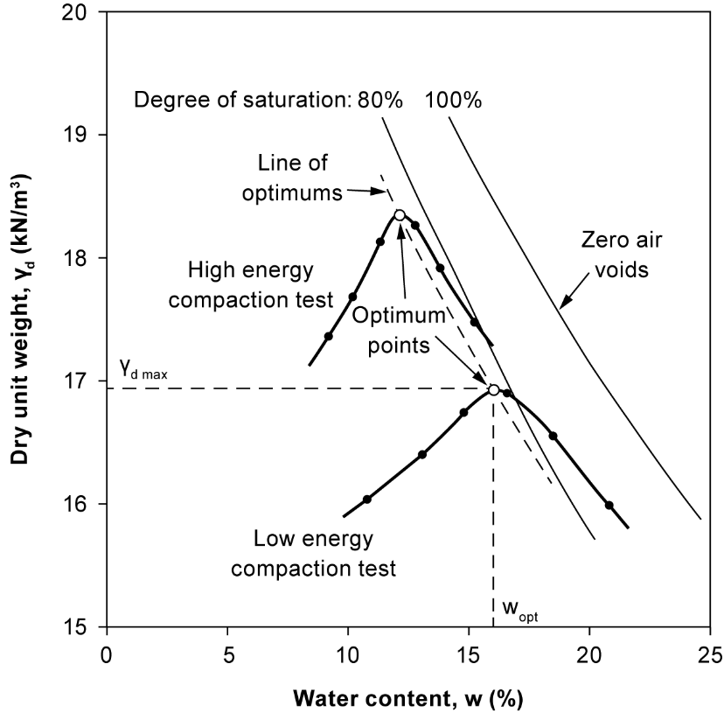
Figure S1. Proposed textbook-case graph of compaction curves obtained in the laboratory (Figure 2 in paper) with commentary on key features. The constant degree of saturation lines were computed for specific density, G_{s} = 2.70. Graph modified from Frendlund and Rahardjo (1993).
Comments: desirable features of the graph
- Y axis parameter is unit weight. (Y axis parameter was modified from original graph.) The pedagogical goal for changing density to unit weight is to familiarize students with the parameter they use in stress calculations and not with density, which is often used in compaction graphs because it is readily computed in the laboratory.
- Axes have numbers and units
- Graph shows both the measured points and the respective compaction curves to underscore that they are produced from separate points (potential drawback: this feature opens the discussion of how we should draw curves from points – however, just omitting the points does not eliminate the need to discuss)
- Graph shows effect of compactive energy with two curves (but no more)
- Graph does not name specific test standards, which might raise a question about relationship between standards discussed in Text S2 (the tests are Standard and Modified AASHTO, this information was removed from the original graph)
- Graph differentiates between optimum points of curves with open circles (points added to the original graph) and the points corresponding to performed tests indicated with solid circles. (Potential drawback related to Comment No 3: compaction specifications involve ρ_{dmax} or γ_{dmax}, a point determined from a curve drawn in a non-unique way.)
- Graph includes at least two constant degree of saturation lines. NOTE In the limited range of densities in a compaction test –see comment by Briaud (2013) in Text S1–, these lines exhibit a similar trend, but they should not look like being parallel, see Figure 2.14 in Frendlund & Rahardjo (1993).
- The specific density, G_{s}, used to compute the constant degree of saturation lines is known. The modified version of the graph includes in the legend of the figure this parameter, which is necessary but of secondary importance.
- The graph includes a line of optimums again in the same general direction of the constant degree of saturation lines but clearly not parallel to them.
Comments: undesirable features of the graph
- The soil type for which the compaction curves were obtained is unknown.
- Finer subdivisions (ticks without labels) would be desirable on both axes to read clearly γ_{dmax} and w_{opt}.

Reference
Frendlund, D.G., Rahardjo, H. (1993). Soil Mechanics for unsaturated soils. Wiley, New York, USA.

Notes on the usefulness of comments
As instructors, we often need to create graphs to visualize data obtained from tests, such as compaction curves. With such graphs, it can be difficult to determine whether students are merely looking at them as shapes or actively extracting the information from the graph, i.e. reading the graph. We can be at least somewhat more confident that students are reading the graphs if we explicitly state what we expect them to read or interpret from them.
The question “what do we want the students to read from a graph” becomes particularly important when we select standard or archetypal graphs for introducing concepts and topics. Writing down explicitly what we expect students to read from the graphs helps us choose our archetypal figure. This is not an easy task if we start with a blank sheet of paper or by examining one specific graph. However, examining many such graphs in different textbooks helps us think “this is useful”, “this is not necessary”, “this would be better if…”. These considerations will become our criteria-specifications for the graph. Most probably, no existing figure will meet all our specifications, so we can modify the figure accordingly in our teaching (more difficult) or at least add a remark (easy). In any case, if we write down our criteria-specifications, we can start a discussion with our colleagues!

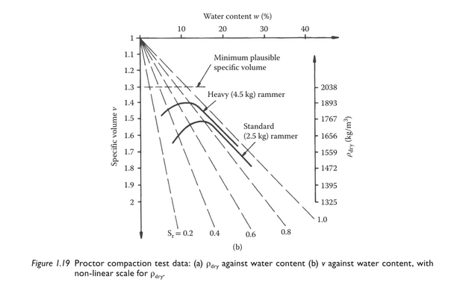

Figure S2. Figure 1.19b in Powrie (2014): compaction curves plotted as specific volume, v, against water content, w, included with permission by the author.

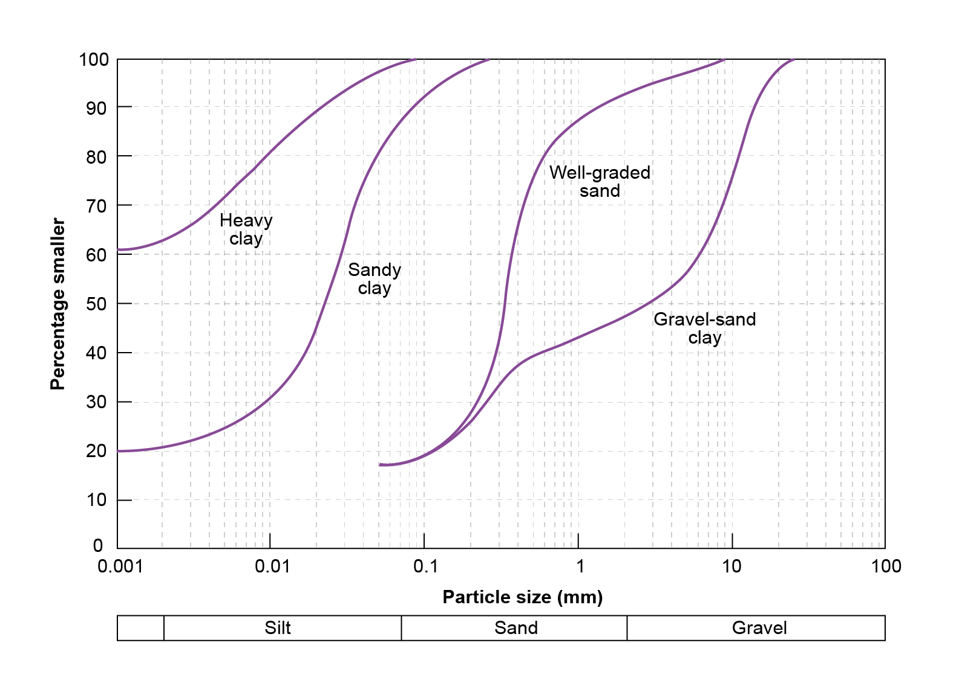
Figure S3. Particle size distributions of trial soils used in evaluating field compaction methods. Redrawn from Croney and Croney (1998).

Reference
Croney, D., Croney, P. (1998). The design and performance of road pavements, 3rd ed. (1st ed. 1977), McGraw-Hill, New York, USA.

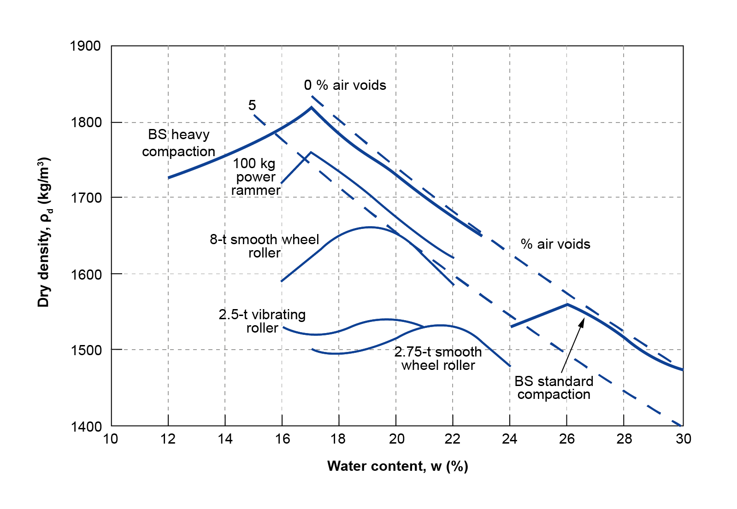
Figure S4. Heavy Clay, i.e. plastic clay (see soil gradation in Figure S3). Comparison of field compaction methods with laboratory compaction tests (curves drawn in slightly thicker lines), performed following the British Standard (BS) standard and heavy compaction procedure. Redrawn from Croney and Croney (1998).
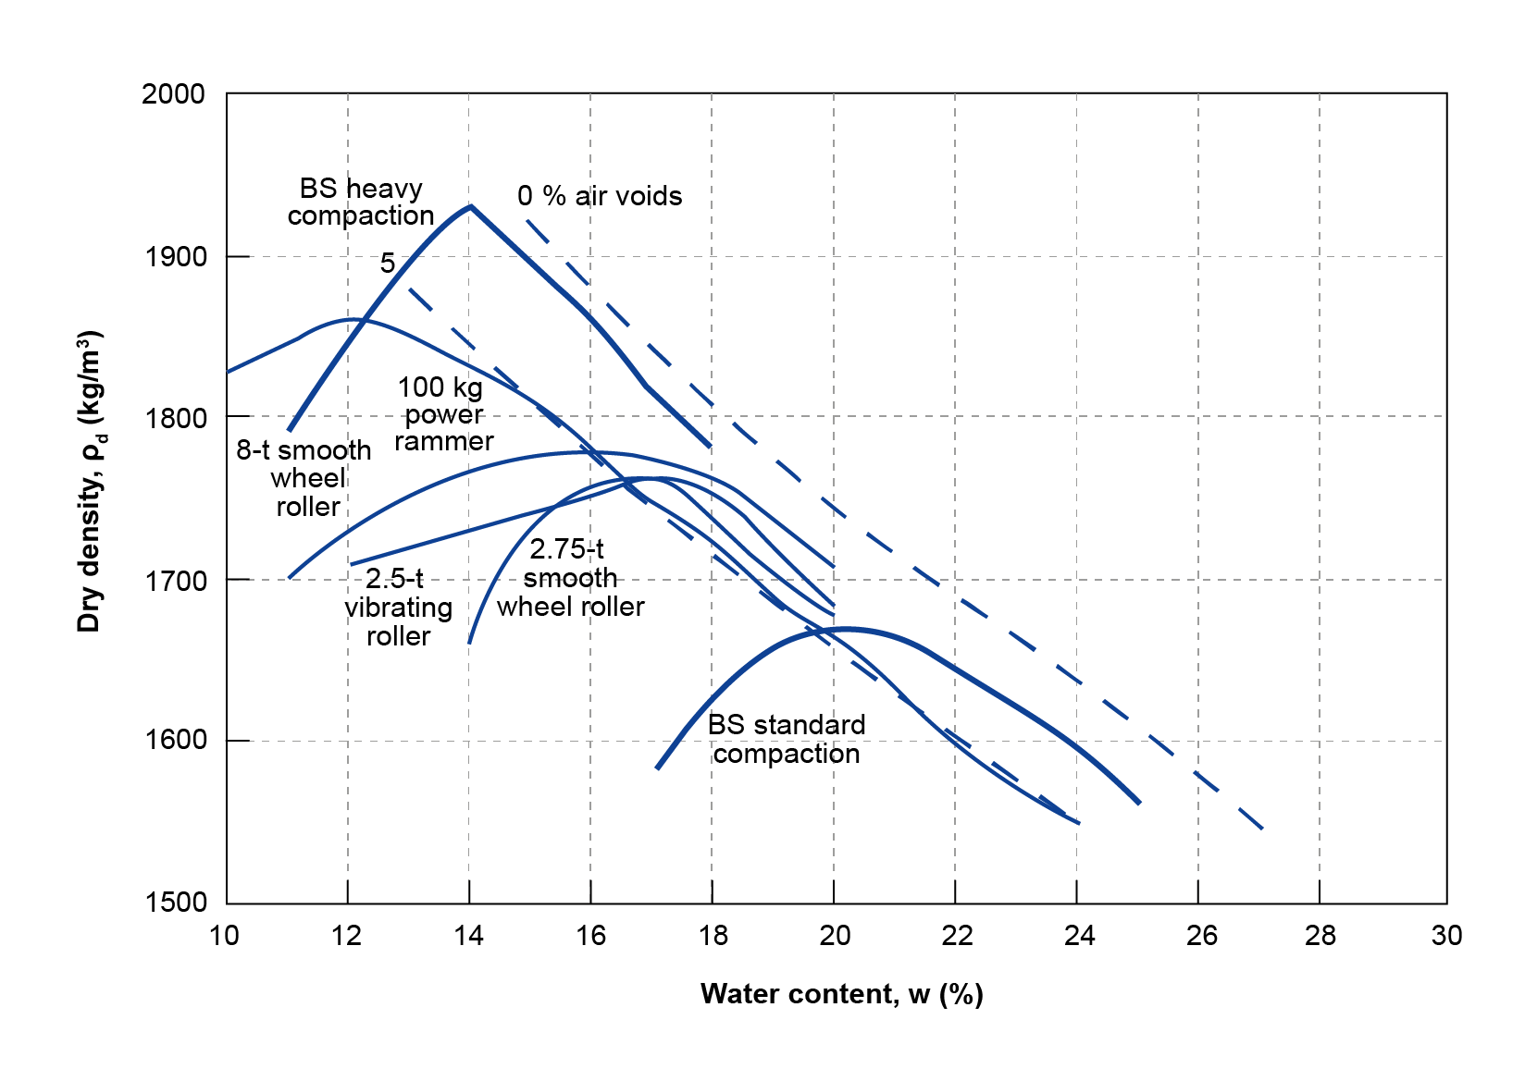

Figure S5. Sandy Clay (see soil gradation in Figure S3). Comparison of field compaction methods with laboratory compaction tests (curves drawn in slightly thicker lines), performed following the British Standard (BS) standard and heavy compaction procedure. Redrawn from Croney and Croney (1998).
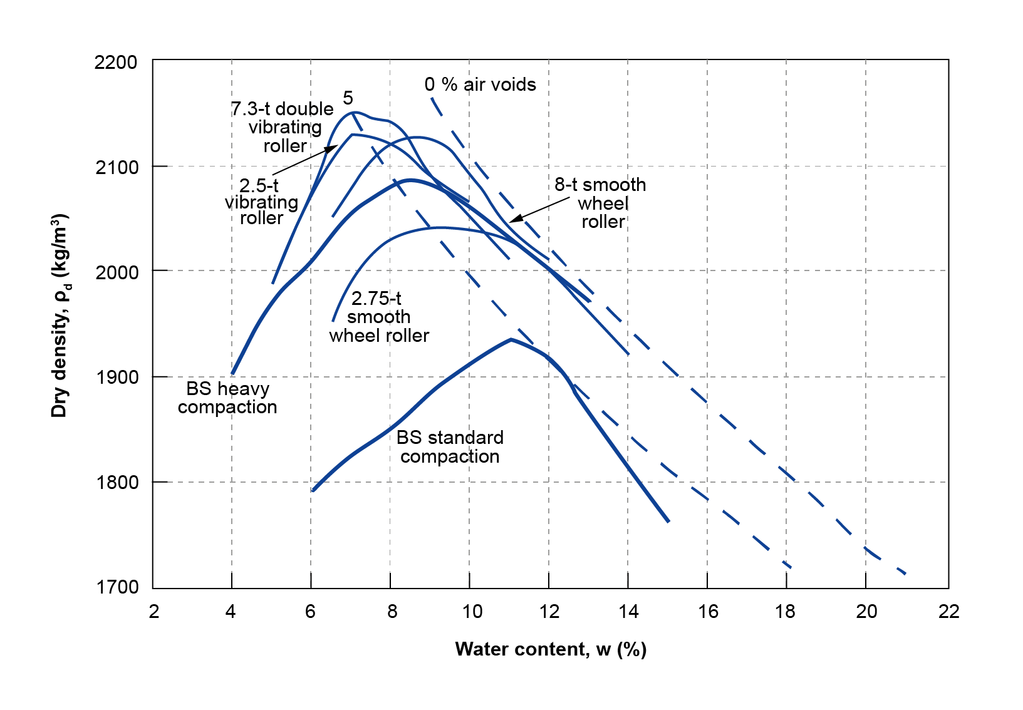
Figure S6. Well-graded sand (see soil gradation in Figure S3). Comparison of field compaction methods with laboratory compaction tests (curves drawn in slightly thicker lines), performed following the British Standard (BS) standard and heavy compaction procedure. Redrawn from Croney and Croney (1998).
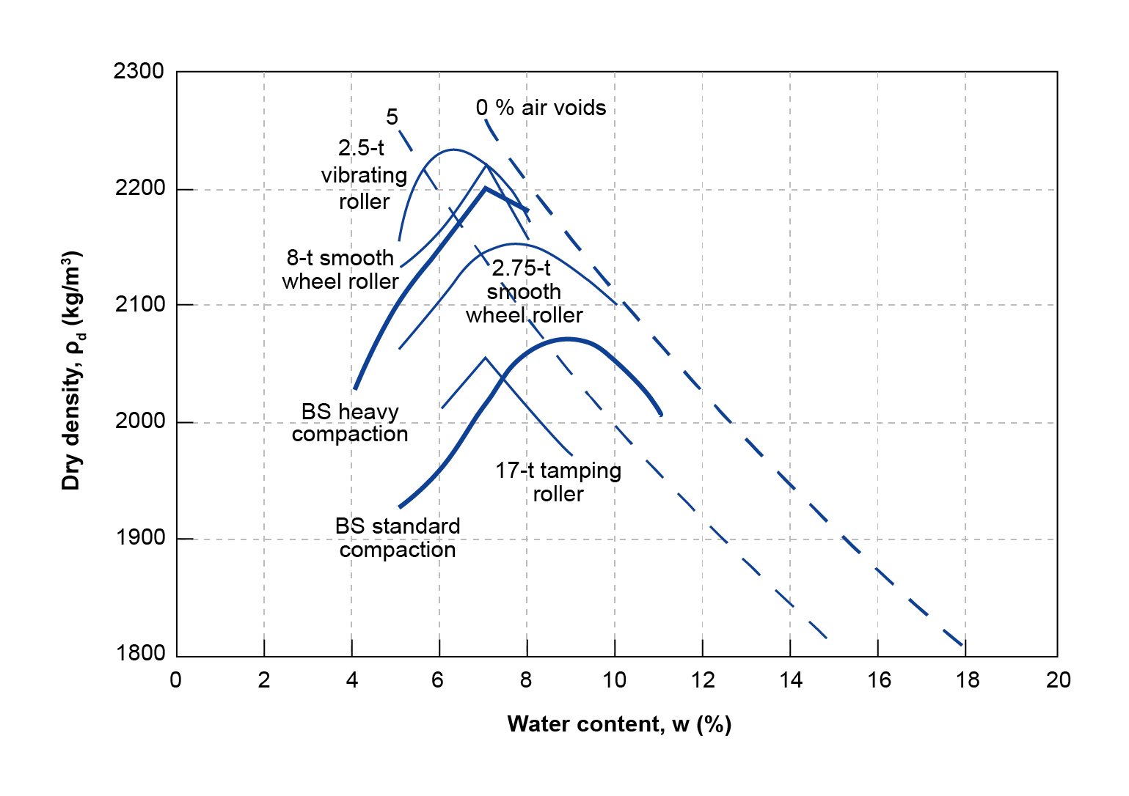
Figure S7. Gravel-sand-clay (see soil gradation in Figure S3). Comparison of field compaction methods with laboratory compaction tests (curves drawn in slightly thicker lines), performed following the British Standard (BS) standard and heavy compaction procedure. Redrawn from Croney and Croney (1998).
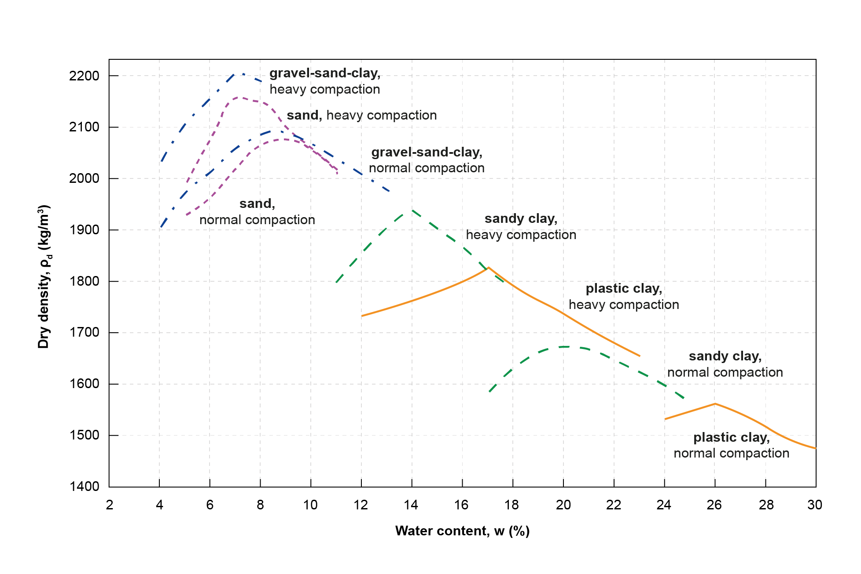
(b)
(a)
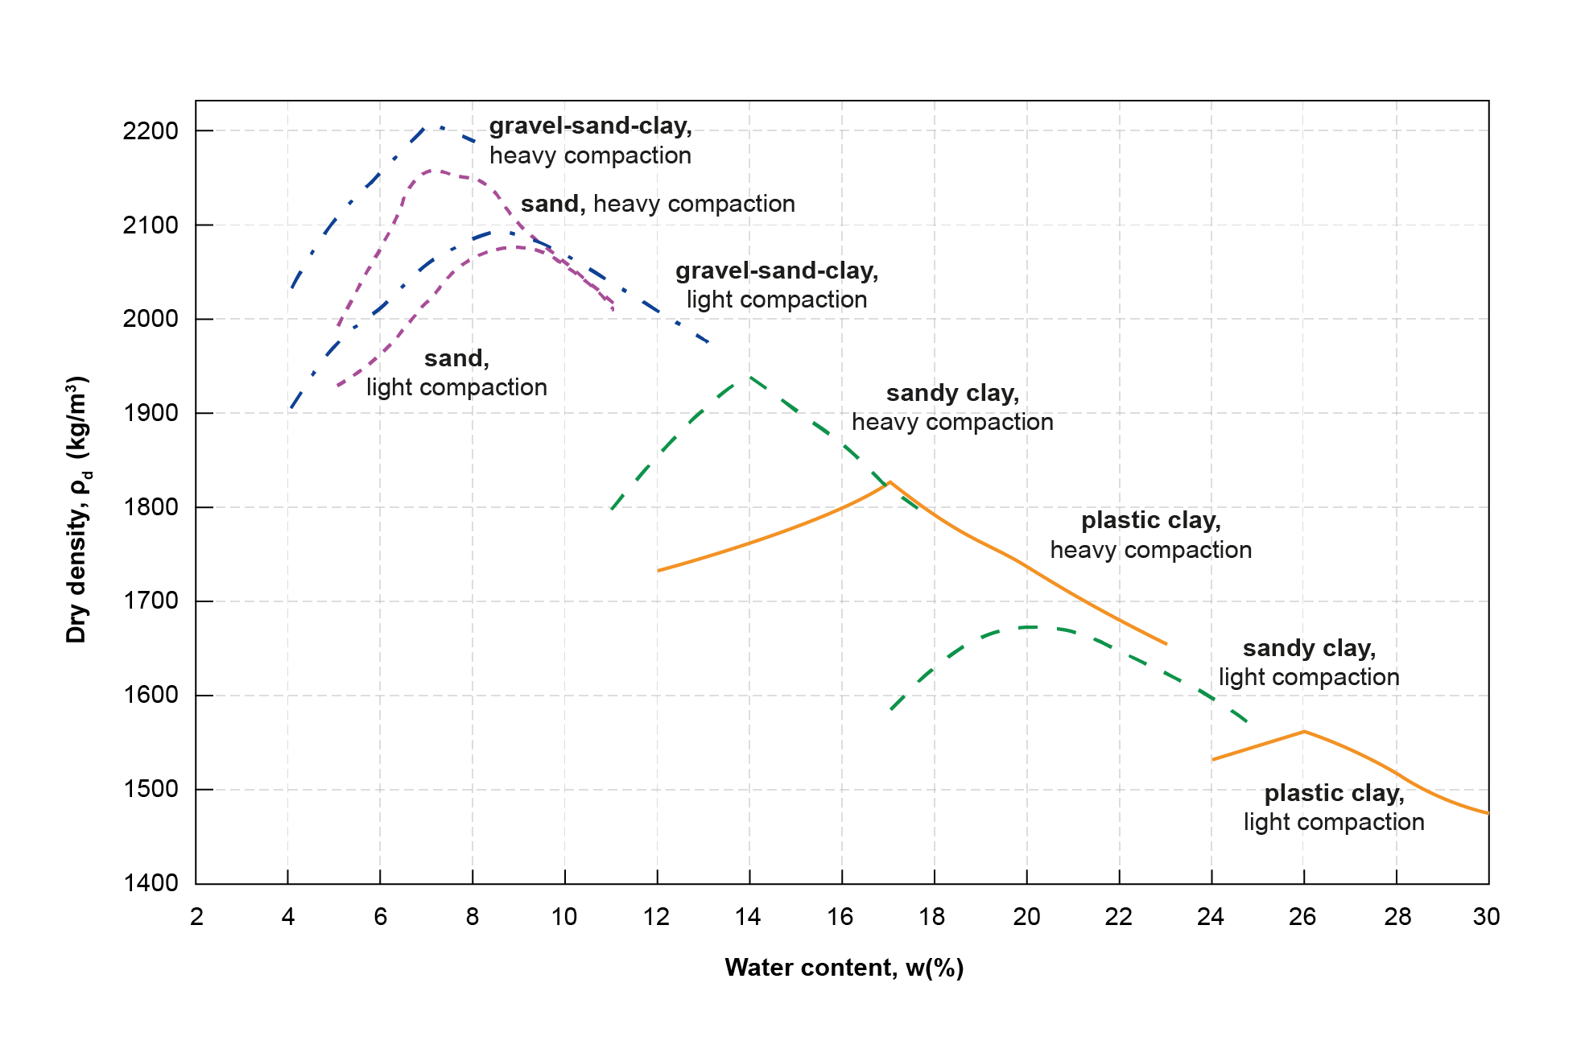
Figure S8. Compaction curves of four different soils (see Figure S3) obtained using two compactive efforts demonstrate the effect of soil particles across soil types: soil particles are to soil what yarn is to textile. Data obtained from Croney & Croney (1998). The specific names of the tests (see Figures S4-S7) are omitted: the standard test is indicated in (a) as “normal compaction” and in (b) as “light compaction” (author’s preference) and the modified test is indicated as “heavy compaction” (see Text S2).
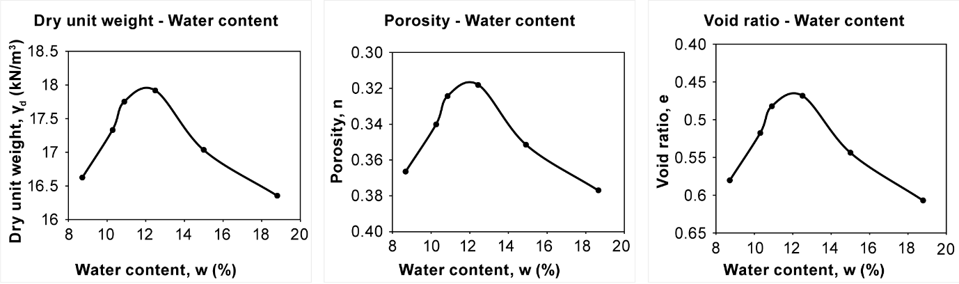
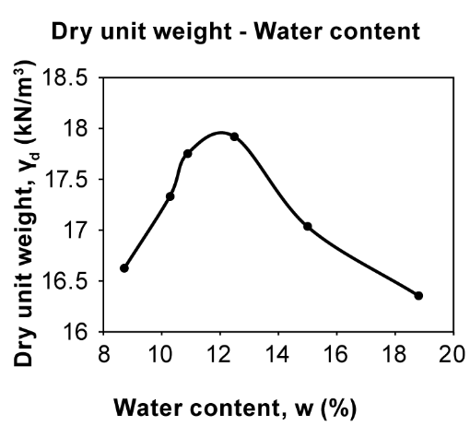
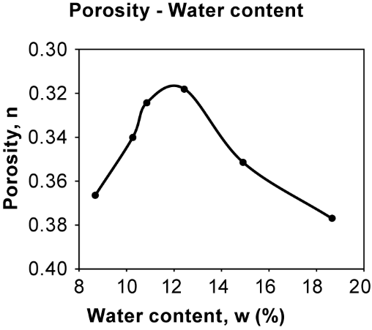
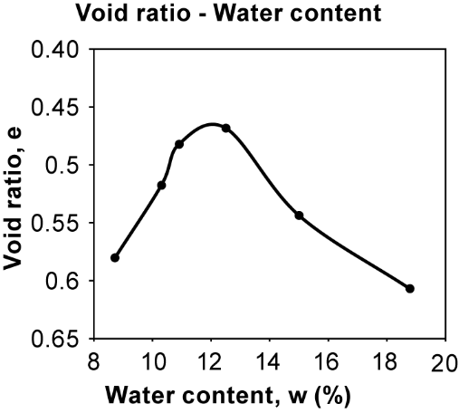
Figure S9. Results from the same compaction test are plotted with water content, w, on the x axis and three different measures of density on the y axis: dry unit weight, γ_{d}, porosity, n, and void ratio, e. Data obtained from: Das, B.M. (1997). Soil mechanics laboratory manual, 5th ed. (1st ed. 1982), Engineering Press, Austin, Texas, USA.

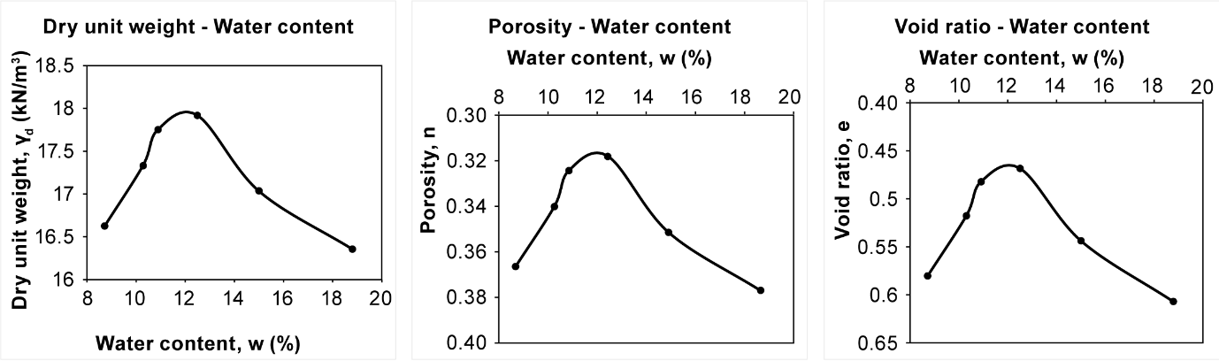

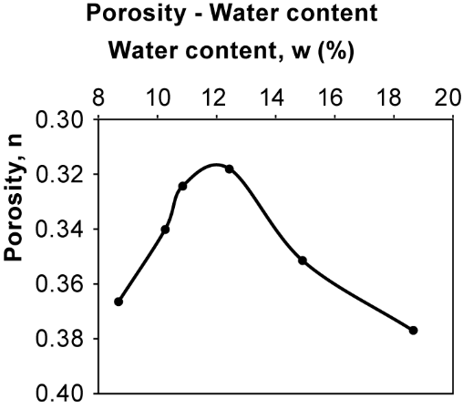

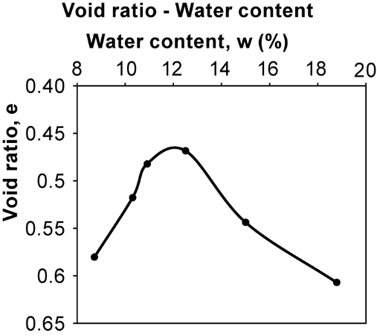
Figure S10. Modified version of Figure S9 for the two graphs in which the y-axis values of porosity and void ratio increase downward. Data obtained from: Das, B.M. (1997). Soil mechanics laboratory manual, 5th ed. (1st ed. 1982), Engineering Press, Austin, Texas, USA.
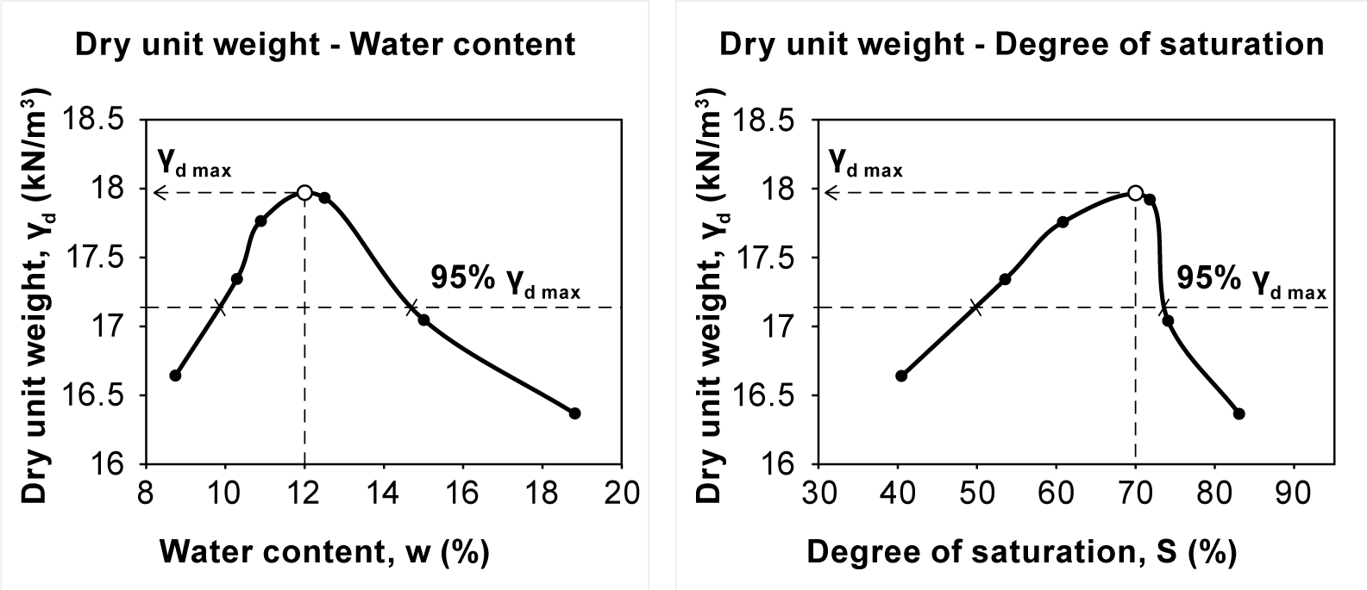

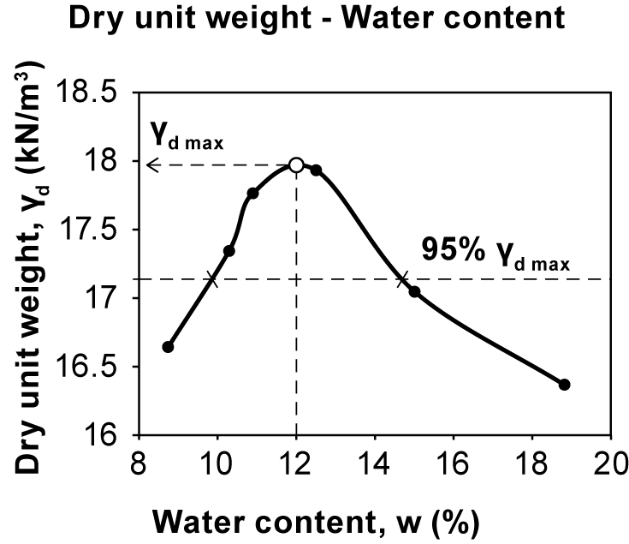

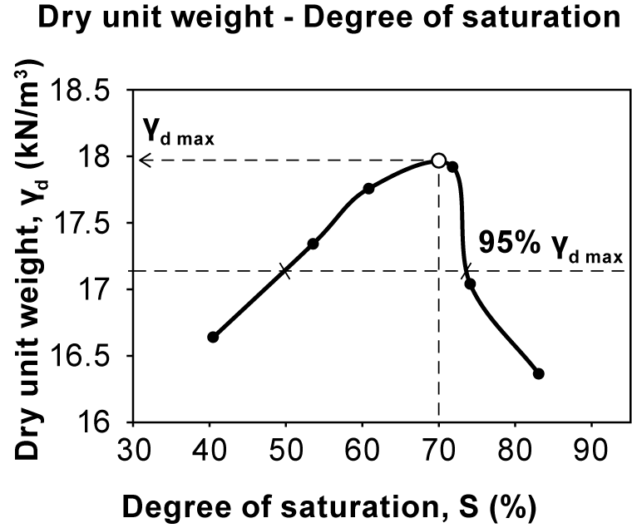
Figure S11. Results from the same compaction test are plotted as dry unit weight, γ_{d}, against water content, w, and degree of saturation, S. The values of degree of saturation are computed for G_{s}=2.68. Data obtained from: Das, B.M. (1997). Soil mechanics laboratory manual, 5th ed. (1st ed. 1982), Engineering Press, Austin, Texas, USA.
Text S2. Note on compaction standards (tentative)
None of the surveyed books discusses the relationship between the usual standards used to perform compaction tests in the laboratory, i.e. Standard & Modified Proctor test, Standard & Modified AASHTO (American Association of State Highway and Transportation Officials) test and British Standard (BS) standard and heavy compaction tests. Often, a specific test is introduced without justifying the choice. Some examples from the more recent textbooks are given next. Budhu (2011) introduces compaction with the aid of the standard Proctor test (but mentions the ASTM D 1557 standard, which is for the modified Proctor test). Briaud (2013) mentions the Standard Proctor and the Modified Proctor Compaction Tests. Knappett & Craig (2012) discuss two tests, the Proctor test and the modified AASHTO test. Powrie (2014) mentions the Proctor compaction test. (References are given in Text S1.)
Only Croney & Croney (1998), in their book on pavements, discuss the relationship between the aforementioned standards and assert that they are the same. First, they give a brief description of the standard test (a weight of 2.5 kg is dropped 25 times from a height of 0.305 m, or 12 in, and the soil is compacted in three layers). Then they write: “This test was originally referred to as the Proctor test, after the originator, but it is now designated as AASHTO Test T99-86, as ASTM Test D698, or as British Standard 1377:1975, Test 12.” Then, they give a brief description of the modified test (a weight of 4.5 kg is dropped 25 times from a height of 0.457 m, or 18 in, and the soil is compacted in five layers). “This test is now designated as AASHTO Test T180-86, as ASTM Test D1557, or as British Standard 1377:1975, Test 13.”
Croney & Croney (1998) also distinguish the two variants of each standard in a descriptive manner: the two compaction tests are generally distinguished by the adjectives “normal” and “heavy”. However, Papaspyrou (2006) uses a Greek adjective for the standard compaction test that is close to “light”. It is possible that the choice of the adjective “normal” is influenced by the adjective of the corresponding test “standard”. For this reason, Figure S8 is given in two versions: one refers to the standard test as “normal compaction” and the other as “light compaction” (which is the author’s preference).
Reference
Croney, D., Croney, P. (1998). The design and performance of road pavements, 3rd ed. (1st ed. 1977), McGraw-Hill, New York, USA.
Links for the respective ASTM standards
https://store.astm.org/d0698-12r21.html, https://store.astm.org/d1557-12r21.html
ChatGPT on comparisons between compaction tests
Before finding the textbook by Croney & Croney (1998), the author was very confused by the different textbooks referring selectively to specific tests without any comment on their relationship.
The answer by ChatGPT was more nuanced than asserting that the three aforementioned standards are the same: “The BS Standard Compaction test and the Proctor Compaction test are not the same, though they are similar in concept.”
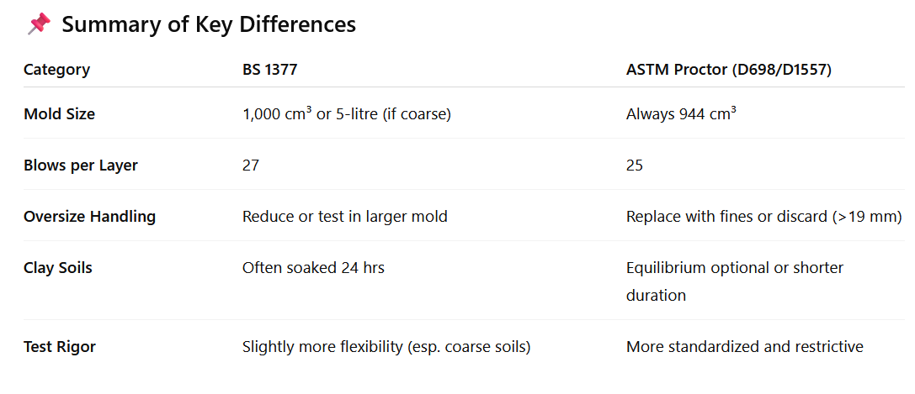
According to ChatGPT, the comparison between Proctor (ASTM) and AASHTO reveals some differences in sample preparation.
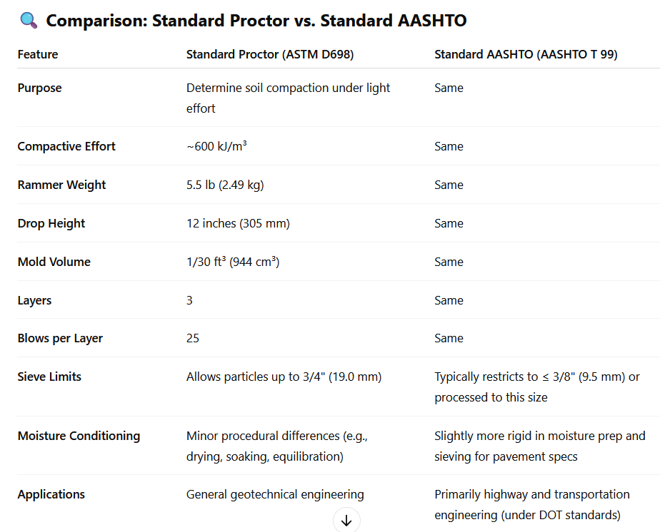
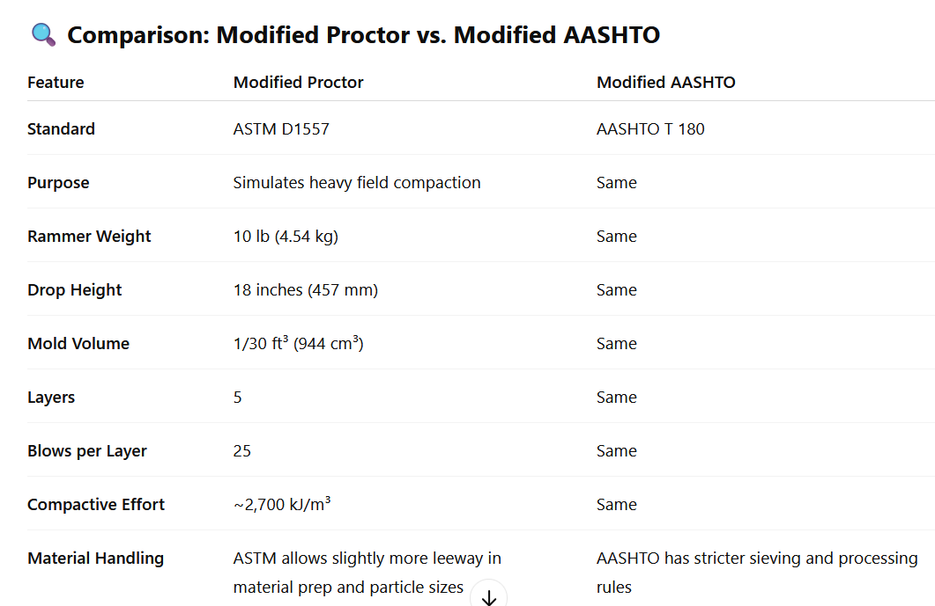

Main take away message
The mechanical process of compaction is identical, but the sample preparation, sieving requirements, and acceptable maximum particle sizes can differ slightly.

Text S3. Note on static vs dynamic compaction (conjectural)
As mentioned in the paper (Section 7.2), the memorable sensory perception of pressing a finger on compacted soil produced the idea of using compaction as a vehicle to represent how dense a soil might be at some sizeable depth below the surface.
Despite its speculative nature, the idea may be worth exploring. One way of making this connection between soil at some depth and compacted soil would be to relate static to dynamic compaction. This relationship was not discussed in any of the surveyed textbooks. The most relevant information was found in Figure 34.4 in Lambe & Whitman (1979), which shows compaction results from laboratory static compaction at 13.8 MN/m² (γ_{dmax} = 18.8 kN/m³), which are quite close to the results of the Modified AASHTO test (then called AASHO) (γ_{dmax} = 18.4 kN/m³). In addition, results from static compaction at 1.38 MN/m² and the Standard AASHTO test were similar (γ_{dmax} = 16.6 kN/m³). The author did not do any further research on this.
In hopes of getting input from more knowledgeable colleagues, the author mentions that the answer of ChatGPT (based on “numerous laboratory studies”) was that a static compaction at 0.4 – 1.2 MN/m² is equivalent to the Modified Proctor Test, i.e. an order of magnitude more efficient when compared to the results in Lambe & Whitman (1979).

